VISVESVARAYA TECHNOLOGICAL UNIVERSITY
BELAGAVI-590014, KARNATAKA
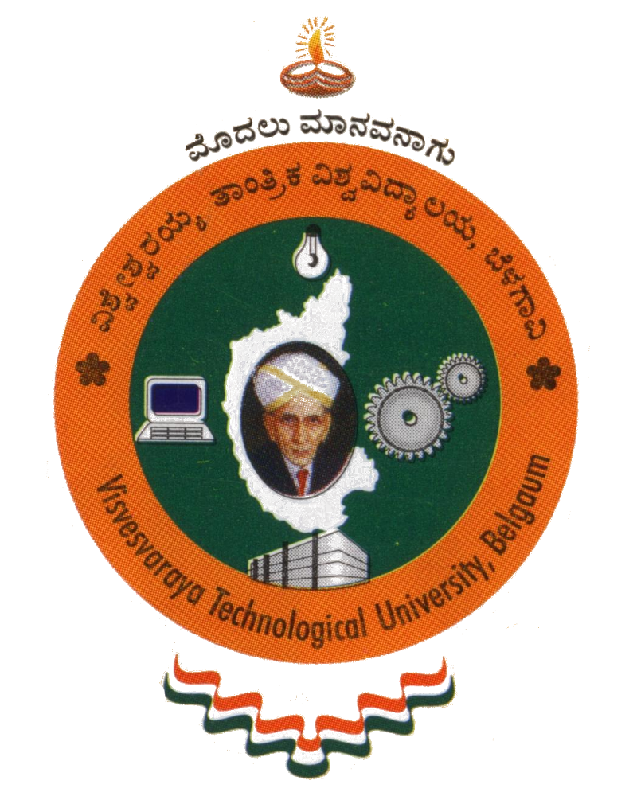
A Mini Project Report
On
“PROJECT MANAGEMENT SYSTEM”
Submitted in Partial Fulfillment of the Requirement for
“DBMS Laboratory with Mini Project -V Semester”
For the Award of Degree
BACHELOR OF ENGINNERING
IN
COMPUTER SCIENCE & ENGINNERING
Submitted By:
PRASHANT YADAV (1SG15CS072)
PRATIK KUMAR SHARMA (1SG15CS073)

Under the Guidance of:
Ms. Veena K R Ms. Shilpa M
Assistant Professor Assistant Professor


Department of Computer Science and Engineering
SAPTHAGIRI COLLEGE OF ENGINEERING
14/5, Chikkasandra, Hesarghatta Main Road
Bengaluru - 560057
2017-2018

SAPTHAGIRI COLLEGE OF ENGINEERING
14/5, Chikkasandra, Hesaraghatta Main Road, Bengaluru – 560057.

Department of Computer Science and Engineering
Certificate
Certified that the Mini Project Work entitled “PROJECT MANAGEMENT SYSTEM” carried out by PRASHANT YADAV (1SG15CS072) & PRATIK KUMAR SHARMA (1SG15CS073), bonafide students of Sapthagiri College of Engineering, in partial fulfillment for the award of Bachelor of Engineering degree in Computer Science and Engineering of Visvesvaraya Technological University, Belagavi during the academic year 2017-2018. It is certified that all corrections/suggestions indicated for Internal Assessment have been incorporated in the report deposited in the department library. The project report has been approved as it satisfies the academic requirements in respect of DBMS Laboratory with Mini Project (15CSL58) prescribed for the said Degree.

Signature of the Guide Signature of the Guide Signature of the HOD
Ms. Veena K R Ms. Shilpa M Dr. Yogish H K
Assistant Professor Assistant Professor Professor & Head

EXTERNAL EXAMINATION

Name of the Examiners Signature with Date

1.___________________________ _________________________

2.___________________________ _________________________

